Sunshine Coast Integrated Care Alliance



Expression of Interest (EOI)

August 2017

Brief overview of the Integrated Care Alliance
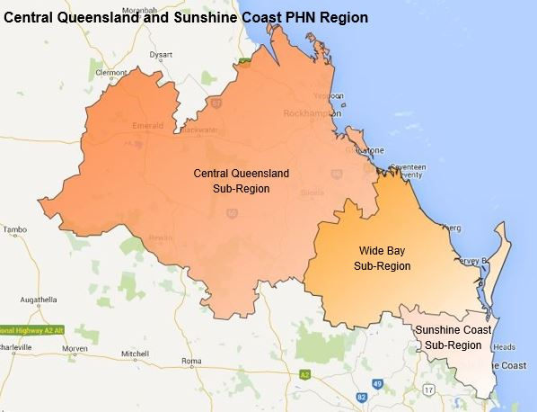
The Integrated Care Alliance (ICA) was conceived with a number of stakeholders; the Sunshine Coast Hospital and Health Service (SCHHS) Central Queensland, Wide Bay, Sunshine Coast PHN (the PHN), Queensland Ambulance Service, North Coast Corporation for Community Health (NCACCH), Silver Chain, Pharmacy representative, Consumer Representative and SC Local Medical Association (SC LMA). In June 2016 an Integrated Care Innovation Funding (ICIF) application was submitted to Queensland Health to establish an ICA on the Sunshine Coast. Whilst the application was unsuccessful, the group decided to move forward in the absence of funding to establish the Alliance, the group has subsequently met several times since then. At the November meeting two important discussions were held; a review of the draft Terms of Reference and membership. A decision was made to generate a list of organisations, stakeholders and community representatives and distribute an Expression of Interest inviting those interested in Integrated Care to apply.
Purpose
The Integrated Care Alliance is a strategic collaboration to ensure integration occurs from an organisational and system level, with the patients at the centre of the health system. The Sunshine Coast Integrated Care Alliance is a willing partnership of all organisations in the local area who share a commitment to deliver person centred care. Each party’s role is to consider the entire patient journey from primary/community based care to tertiary facilities.

Expression of Interest
Sunshine Coast Integrated Care Alliance now invites submissions from individuals/organisations who are interested in becoming an active or associate member of the Alliance.
Applications are encouraged from industry leaders who share a commitment in delivering person centred care. This may include:
- Aboriginal & Torres Strait Islander representatives
- Academics or advisors
- Consumer, family, carer advocates
- Health, Education and Community
- Justice

- Local, State, Federal Government Members or representatives
- Peak Body representatives
- Private, Public and Non-Government sector representatives
- Specific primary, secondary, tertiary and quaternary health, wellness, lifespan or care issue representatives
- Housing sector
For more information please refer to the Sunshine Coast Integrated Care Alliance Terms of Reference (ToR).

To submit applications:
Step 1: Nominate which membership type you wish to apply for.
Step 2: Complete the ‘Personal Information’ section below and include with your application.
Step 3: Provide information demonstrating your interest and experience (personal and/or professional) and suggest how this can contribute to the success of the Sunshine Coast Integrated Care Alliance. Please also note any actual (or perceived) conflicts of interest in this section.
Step 4: Email your completed Expression of Interest form and supporting documents to
Jane Campbell - Regional Manager Clinical Strategy & Development and
Clinical Council Coordinator
If you have any questions relating to this application, please feel free to contact Jane Campbell on:
Phone 07 5456 8100, or email jcampbell@ourphn.org.au
Step 1: Membership type
Please select your preferred Membership option below (see highlighted text box):
Active Member
To be eligible for active membership you:
- Have a minimum of three years’ experience working in a health or social care organisation
- Spend a majority of time in this industry
- Are willing or able to contribute toward the aims and objectives of the Alliance
- Can vote on new members and for the position of Chair.
Associate Member
Individuals not eligible for active membership, but interested in contributing to the Alliance. This membership does not have any voting rights.
I would like to apply for the following Membership: ACTIVE / ASSOCIATE

Step 2: Personal Information
Title: Click here to enter text. First Name: Click here to enter text. Last Name: Click here to enter text.
Gender: Click here to enter text.
Phone Number: Click here to enter text. Email Address: Click here to enter text.
Role or Occupation: Click here to enter text.
Employer (if relevant): Click here to enter text.
References
Please list contact information of two referees who are able to provide details of, and confirm your skills and experience.
Referee 1
Title: Click here to enter text. First Name: Click here to enter text. Last Name: Click here to enter text.
Organisation: Click here to enter text.
Phone Number: Click here to enter text. Email: Click here to enter text.
Referee 2
Title: Click here to enter text. First Name: Click here to enter text. Last Name: Click here to enter text.
Organisation: Click here to enter text.
Phone Number: Click here to enter text. Email: Click here to enter text.

Step 3: Information Demonstrating Interest and Experience
To be considered for appointment, the applicant’s suitability will be assessed based on the following information (maximum 1 page). Please provide your responses below, and attach any additional documents to support your application form.
3.1. Area of interest and expertise (please limit to 3 areas):

3.2. Please describe your health, community or social sector background, including experience or interest with Integrated Care in your local region.

3.3. Please outline your motivation for joining the Sunshine Coast Integrated Care Alliance. What is it that you want the Integrated Care Alliance to achieve?

3.4. Please outline your experience in working as part of a strategic group or organisation. List any health, community, education, social sector or other advisory groups that you are a working member of at present.

3.5. Please outline any perceived, potential or actual conflicts of interest that may exist if you were successful in this role?

